Continuous Integration pipeline

1. Which is also known as Azure DevOps pipeline
2. Before doing CI We must have version control system and inside that a code should be present
3. CI and CD is like automating the process right from checking the code

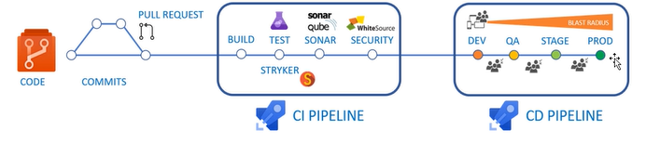

1. Output of CI pipeline becomes input for CD
2. Agent is an application/service which has to be installed in one machine which is responsible for executing the tasks like BUILD, Test, sonar Qube and security
3. Pipeline which will create using devops portal and pipeline when it executes it becomes run when it runs it needs an agent to execute all the steps
4. There are two types of agent present one is Microsoft hosted agent and self-hosted agent
5. Agent is machine which is installed in the machine and which is responsible for execution of the instructions as specified in the pipeline when the pipeline is put in Run mode
6. Agent is installed software in the virtual machine the Virtual machine is managed by Microsoft which is called Microsoft hosted agent, or we create the VM and we will manage it called self-hosted agent
7. When ever we run the pipeline, the steps mentioned in the pipeline will use the Agent to execute on a given hosted agent( it is a machine where machine is hosted)
8. Microsoft hosted agent VM every we will run Microsoft hosted agent VM is freshly initialized first in that VM all particular steps will be executed and when the pipeline ends the hosted agent is destroyed and we cannot retain that
9. VM is created > steps are executed on the pipeline agent on it > all the steps completed agent is destroyed.
10. When the RUN to be happened there should be some trigger(when we do a commit into a particular branch automatically the pipeline has to be executed. Or we can trigger the pipeline when pull request is successfully completed.
11. I can trigger the pipeline at a particular fix or a day or we can do manual
12. Because of the trigger the Run is going to start
13. The result of pipe line creation is always to be an output generated
14. That output is saved in devops in the form of artifacts (when the run Is finished the Microsoft hosted agent will end and will demolished by itself so where the out put will be saved and it is saved in the form artifacts)
15. The final product of build pipeline is a build antifact

For example, an artifact can be:

• A Java or .NET application packaged into a .jar or .zip file.

• A C++ or JavaScript library.

• A virtual machine or Docker image.

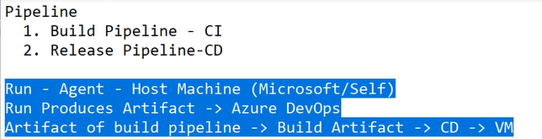

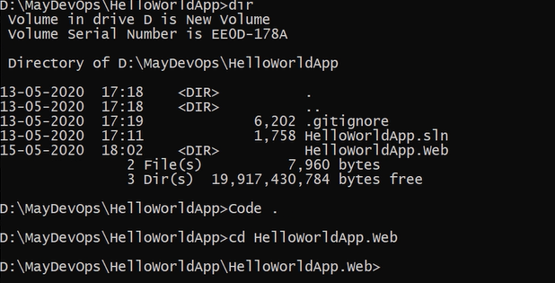

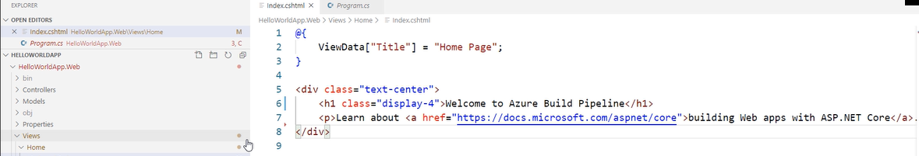

Dotnet restore > in developing the application we might actually add reference to third party libraries, and this are done by nuget packages.

Dotnet restore is going to pull all nuget packages from nuget gallery ( it is a location on internet from where we added a reference to the third party components into our project) those packages are going to pulled on the local machine

After dotnet restore we need to run dotnet build

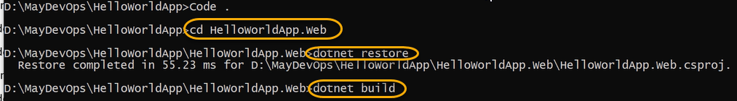if it is success then it will show like below

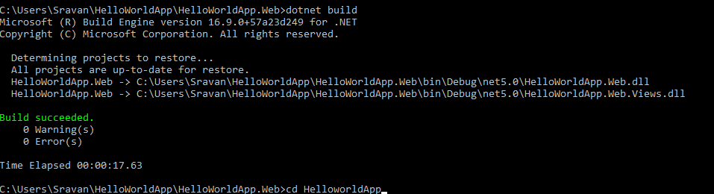

If it is failure

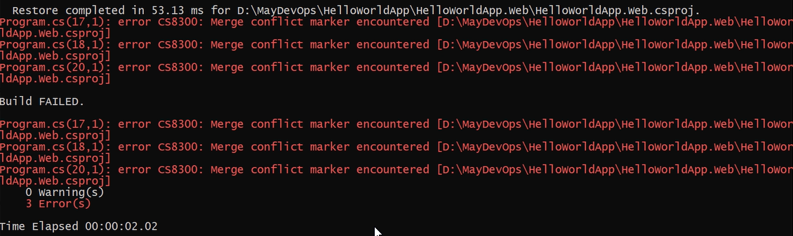

If is failed we cannot compile the project

Code .

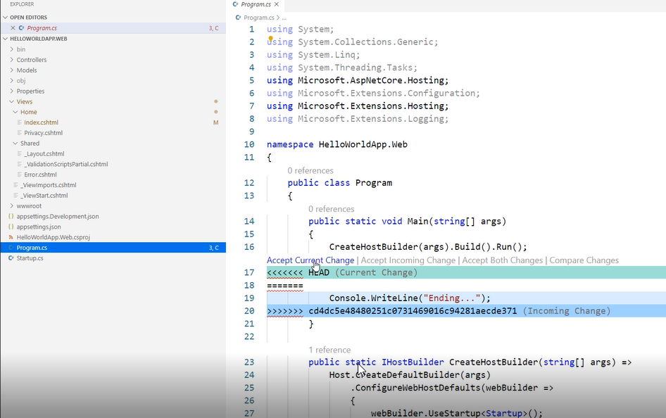

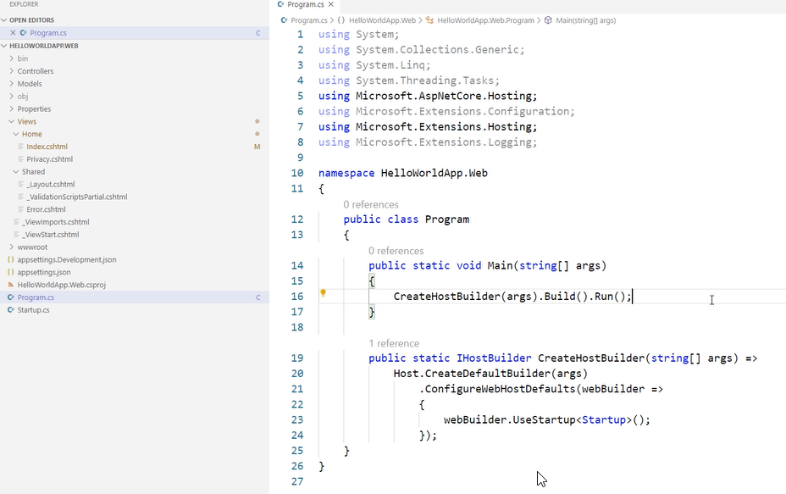

I want to use the execution of webapp application

When we are going to use the pipeline

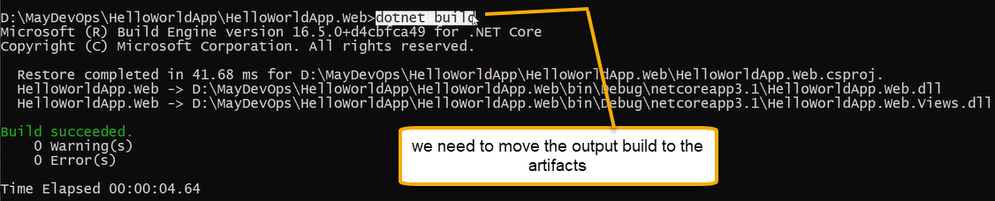

As of now we are doing to this process manually however we need to it automation build through pipeline

Configuration debug will do at which line the code will fails we can debug accordingly but it is little slow in performance Configuration release is faster in performance,but it is not suitable for debugging

If you are going for development, you should go for debug configuration build but if you are going for production you should go for Releasethe artifact generated in Release it will move into the production application

The artifact generated in the debug will move into the development and testing machine

On my local machine we need to execute HelloWorldApp.Web.dll

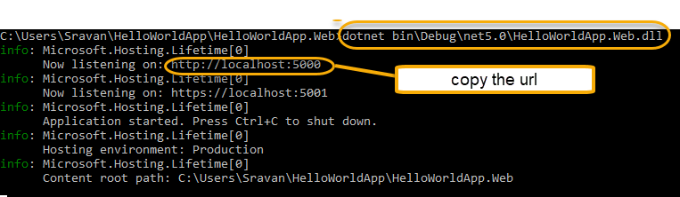

And paste in google

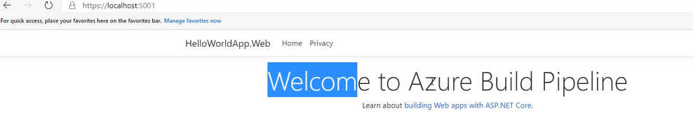

Ctrl+ c is to stop the server

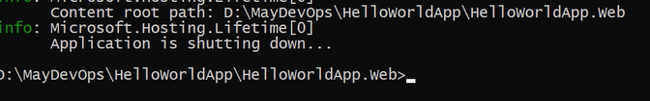

We need to move into the destination machine

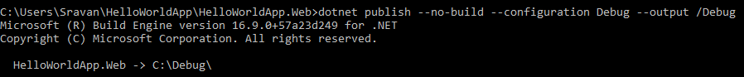

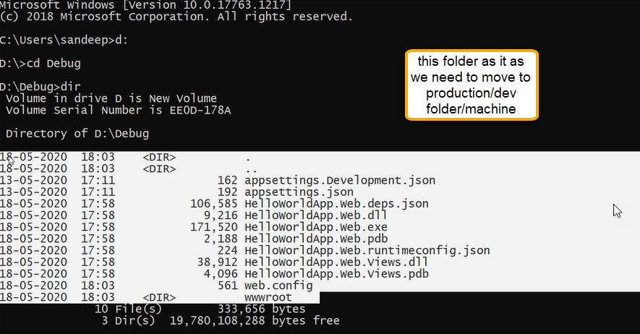

For the commands we are going to create the task

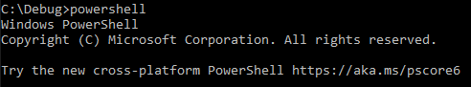

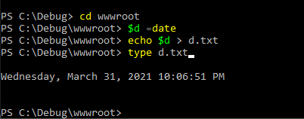

Or

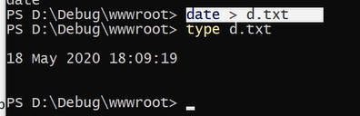

EVERY COMMAND YOU EXCEUTE IN THE COMMAND PROMPT CAN GO INTO THE PIPELINE

WE NEED TO RUN ALL THE COMMANDS IN PIPELINE

In Azure DevOps, you can use one of two methods to configure a pipeline:

1. The visual designer. Here, you drag tasks onto a form and then configure each task to do exactly what you

need.

2. A YAML file. YAML is a compact format that makes it easy to structure the kind of data that's in

configuration files. You typically maintain this YAML file directly with your application's source code

YET ANOTHER MARKUP LANGUAGE

Whatever we have locally we need to push to azure repo

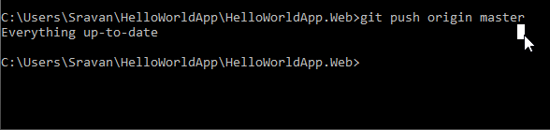

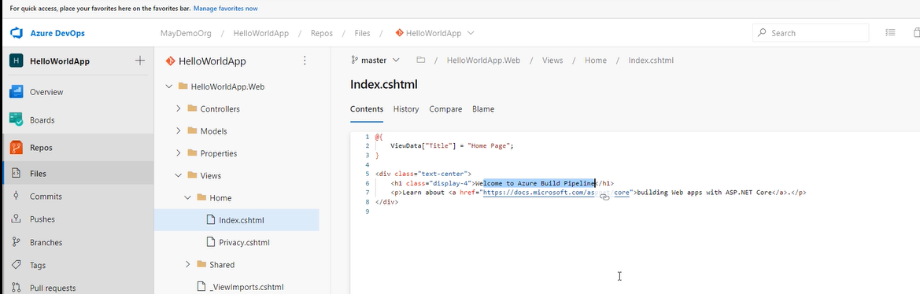

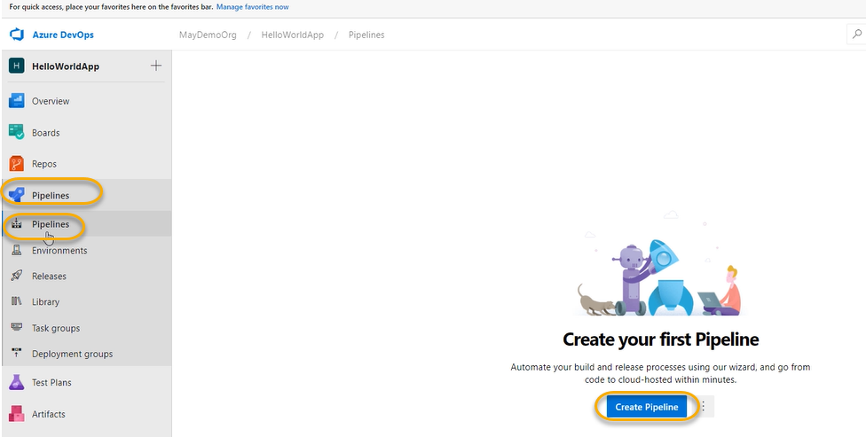

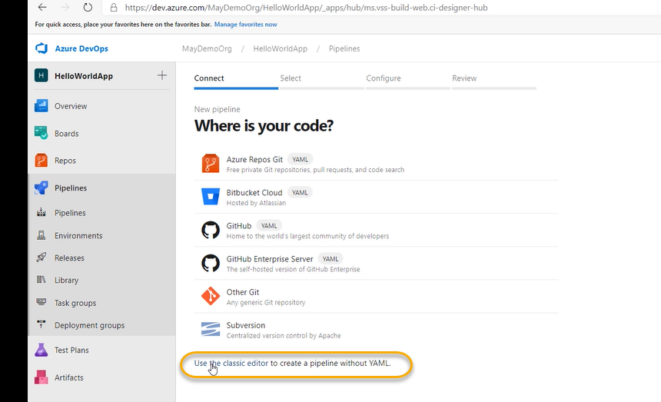

However above one is NOT recommended way

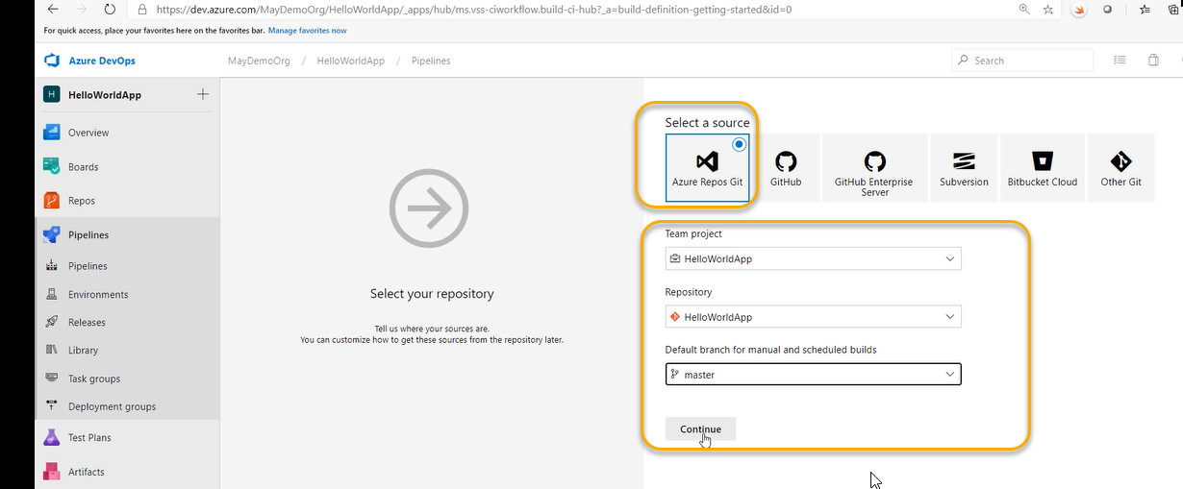

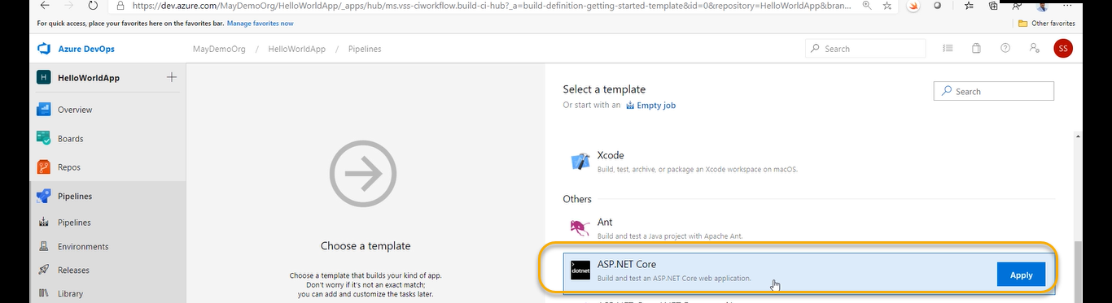

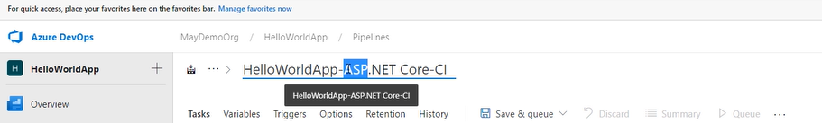

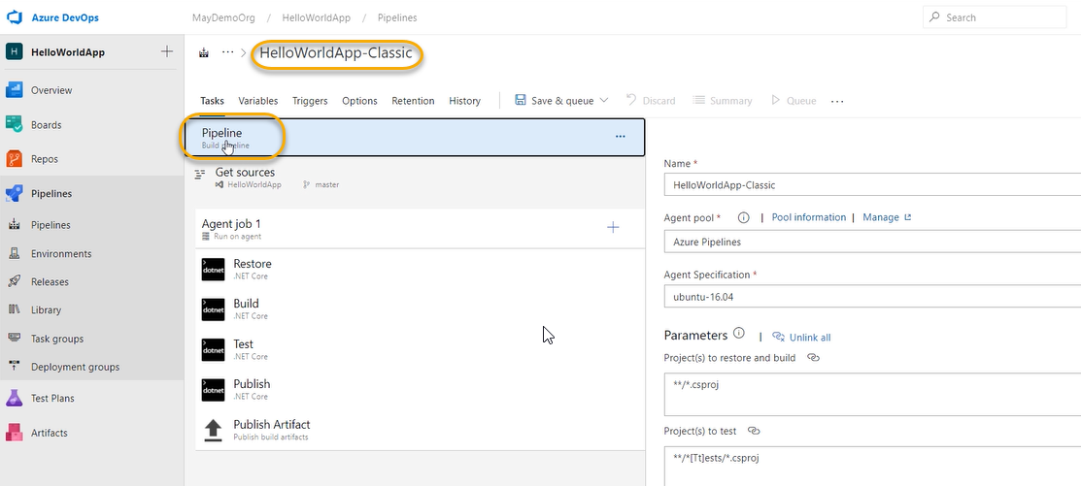

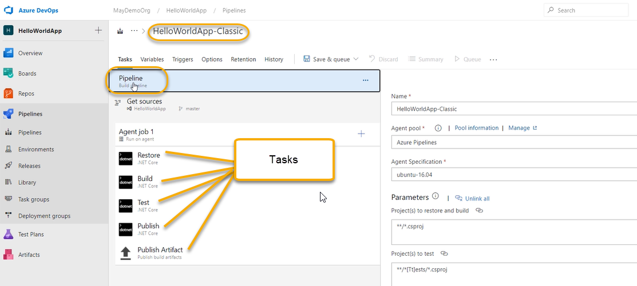

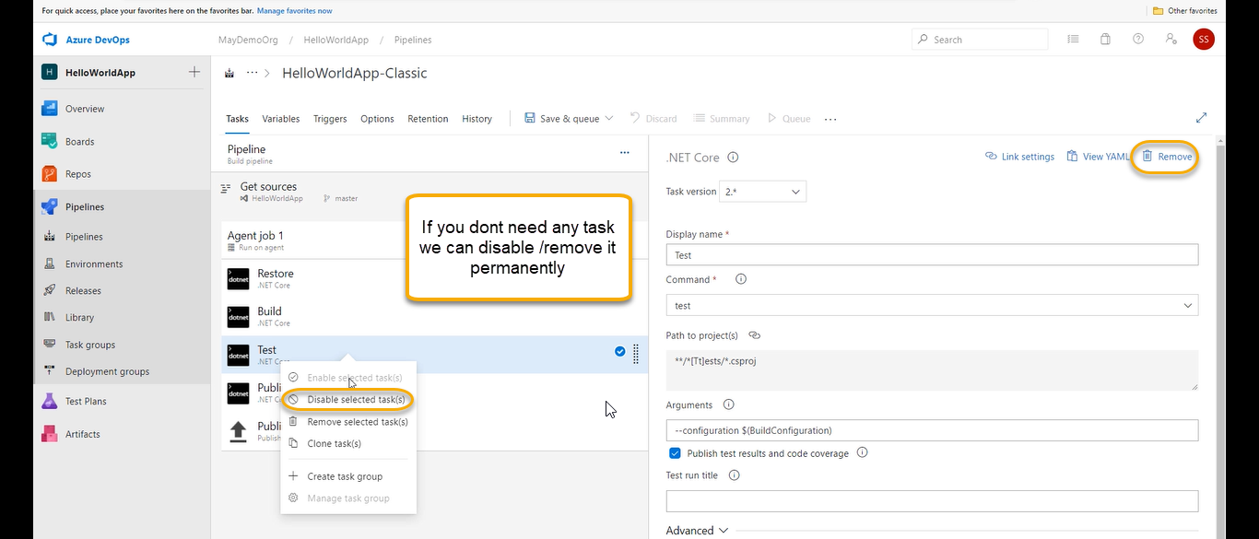

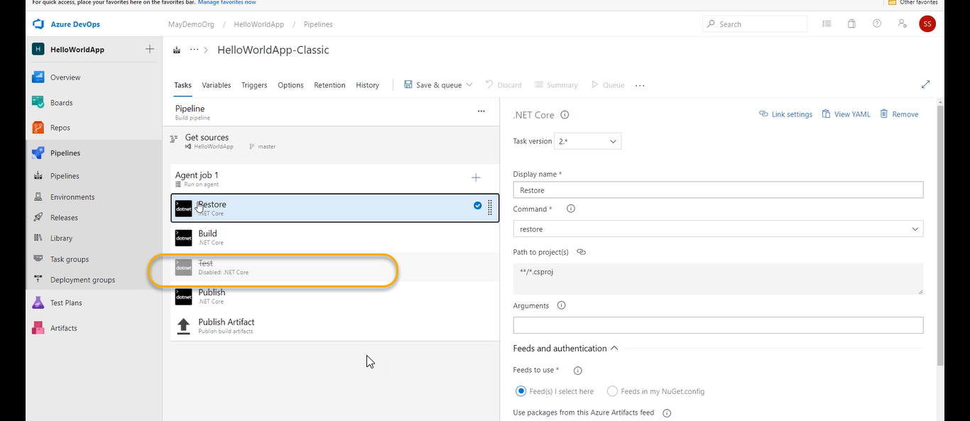

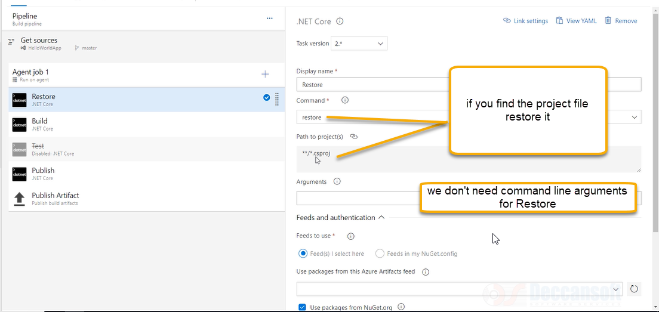

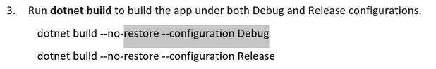

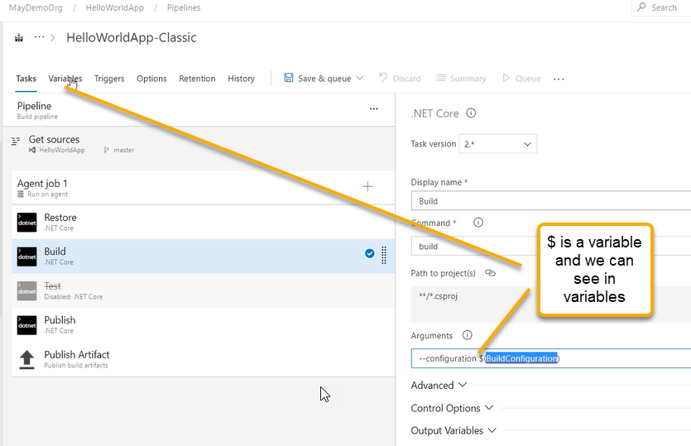

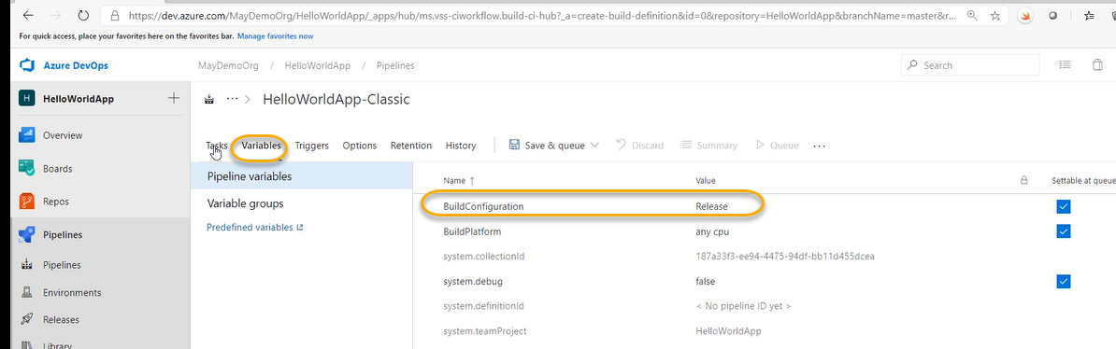

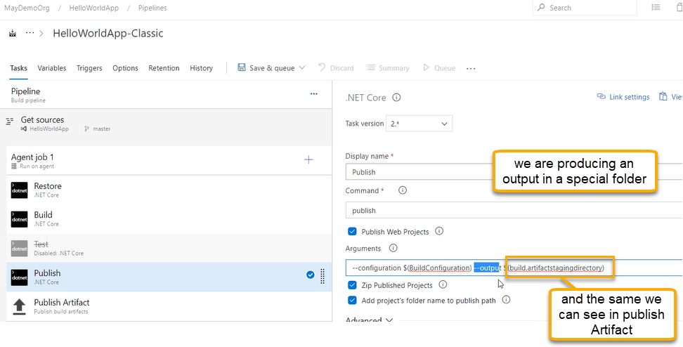

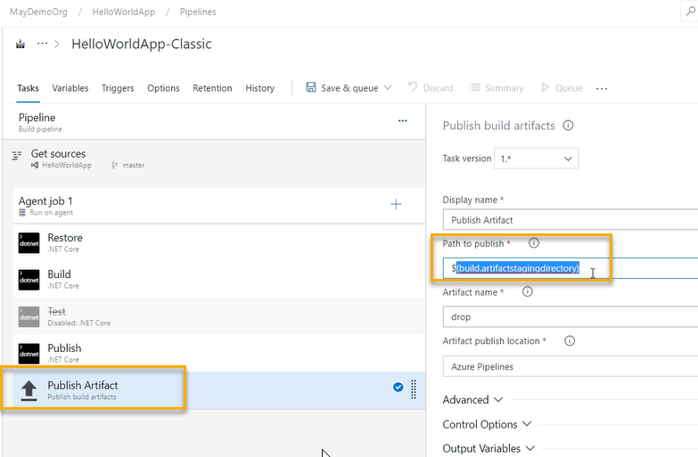

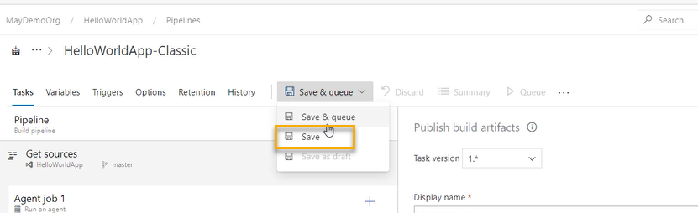

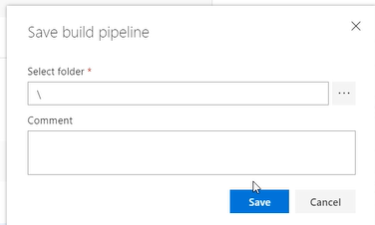

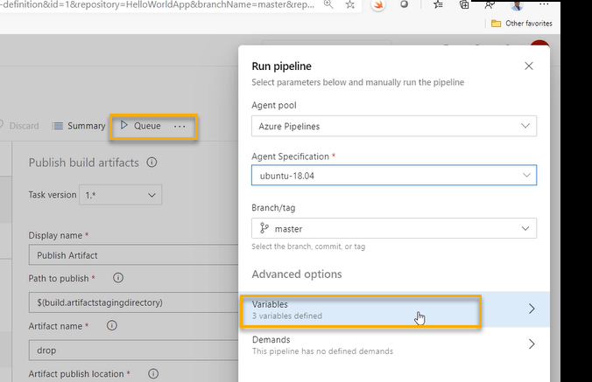

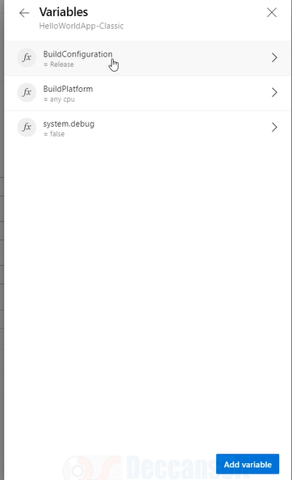

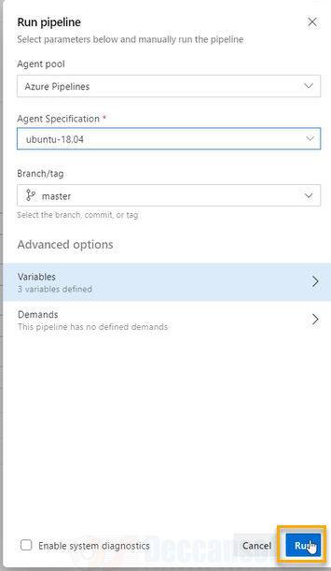

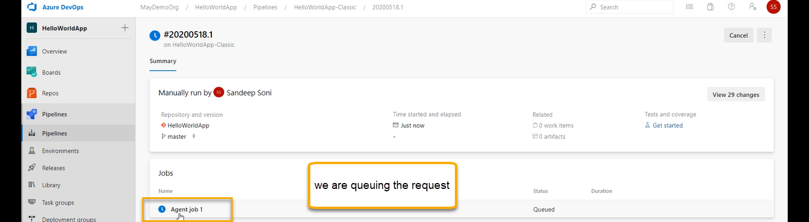

And now it is in queue

Waiting for Microsoft hosted agent when ever my pipeline gets triggered a Microsoft hosted agent it will start executing.

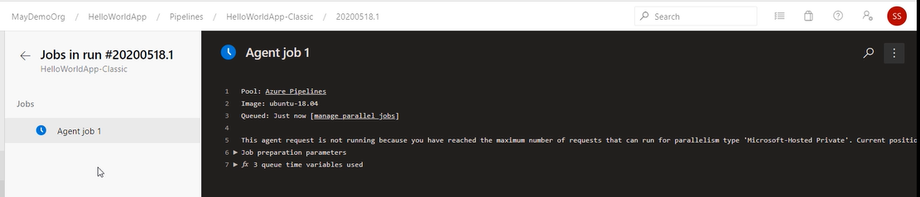

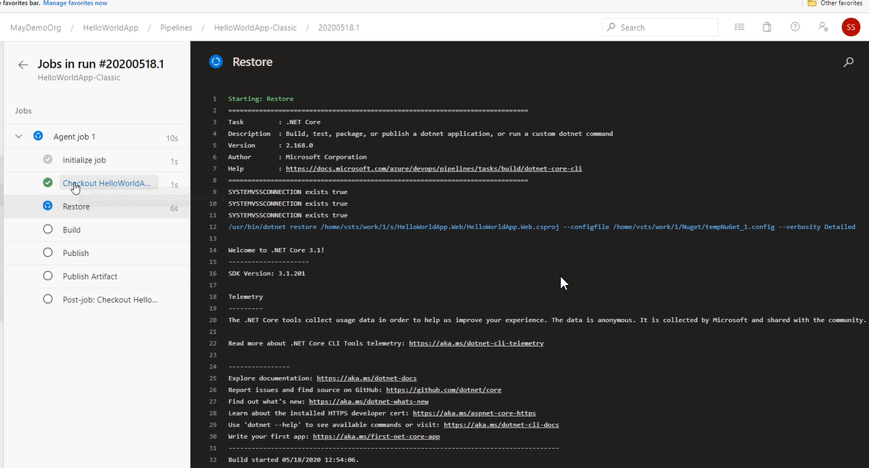

The agent machine in the first machine has stepped out

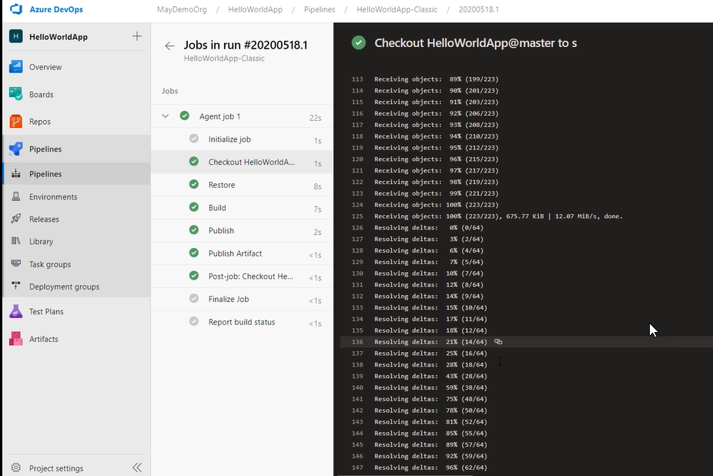

All the objects are received on the local machine

Agent > on that machine from Azure repo the code is fetched

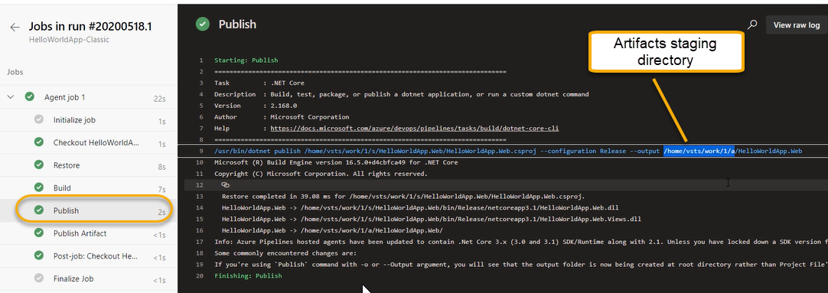

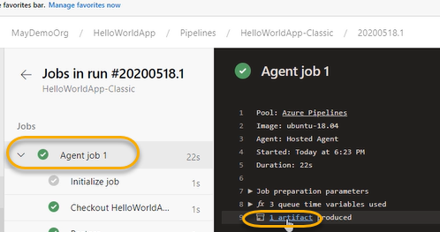

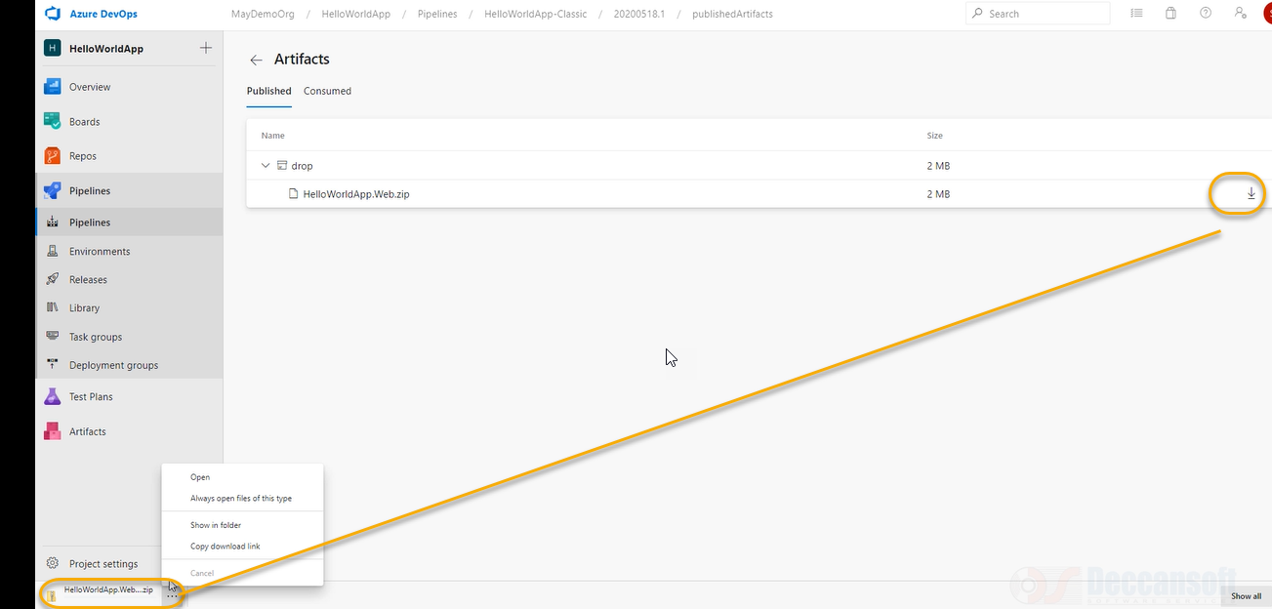

We are getting the zip file because we have configured as below

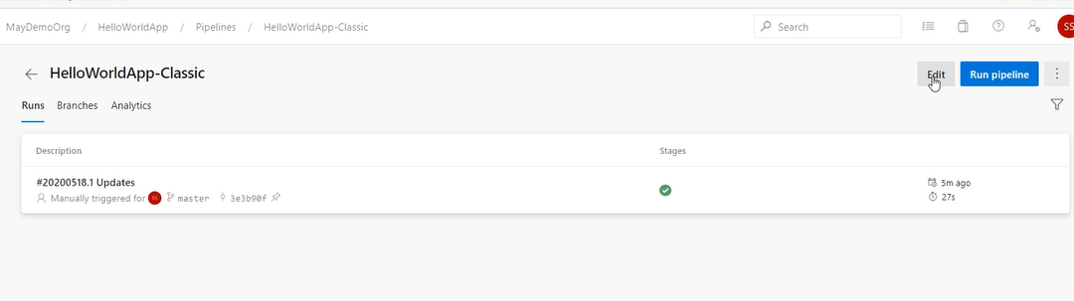

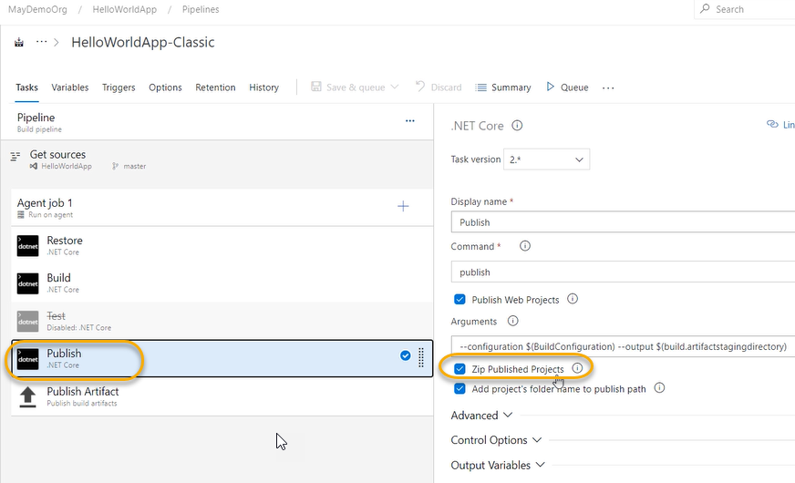

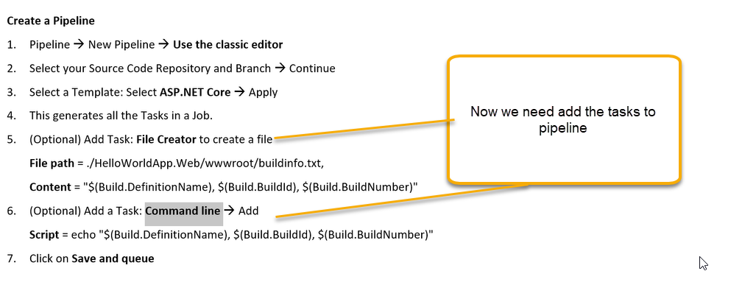

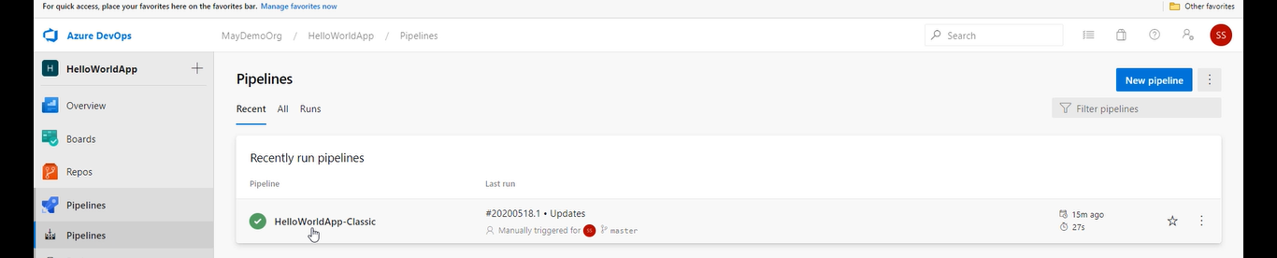

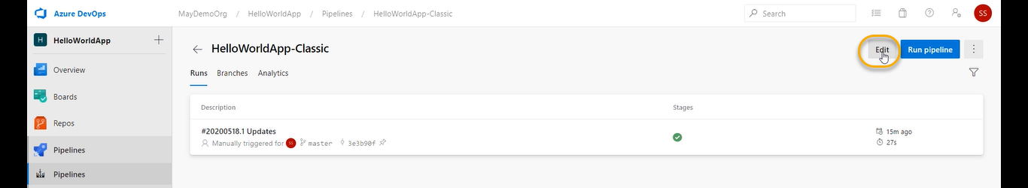

We need to add file creator which is responsible in creating the file

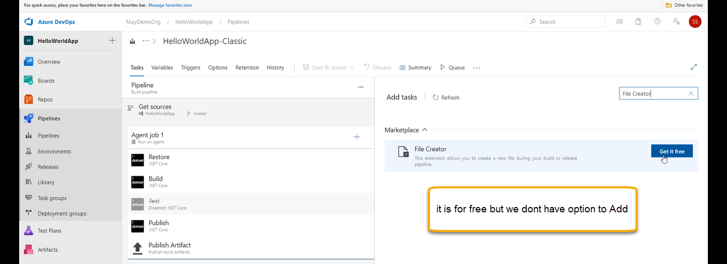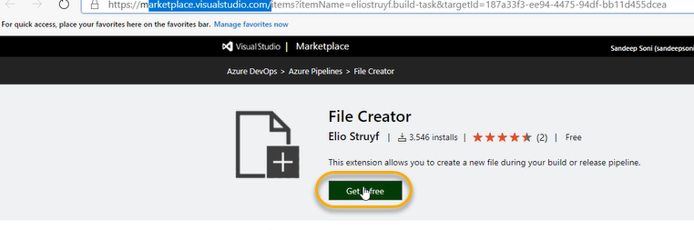

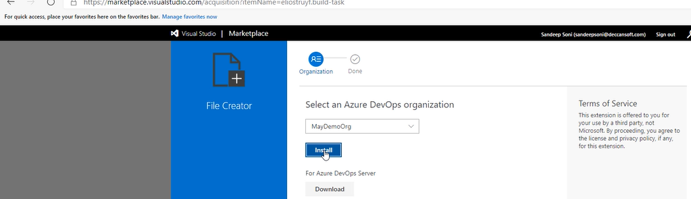



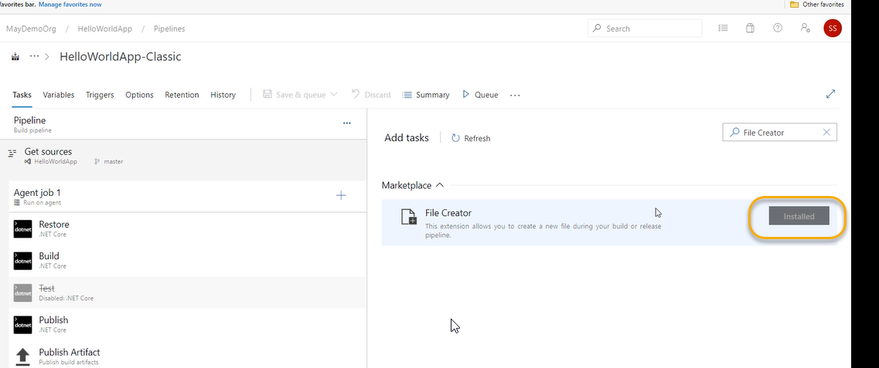

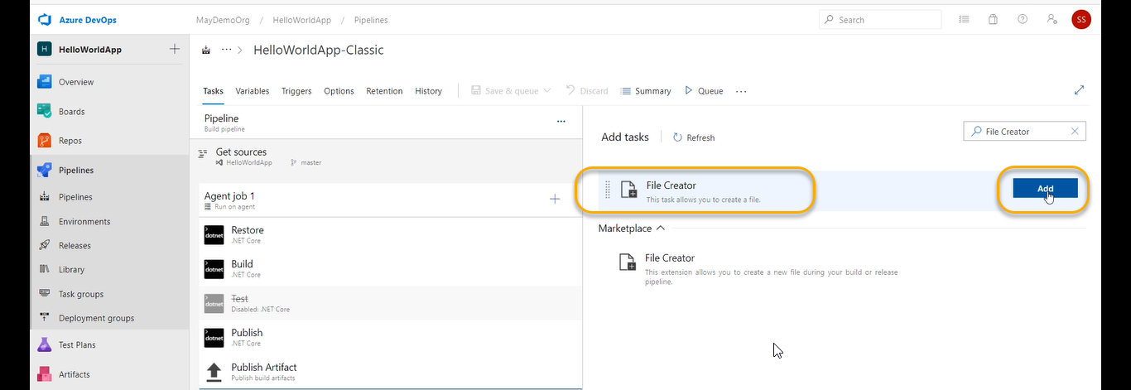

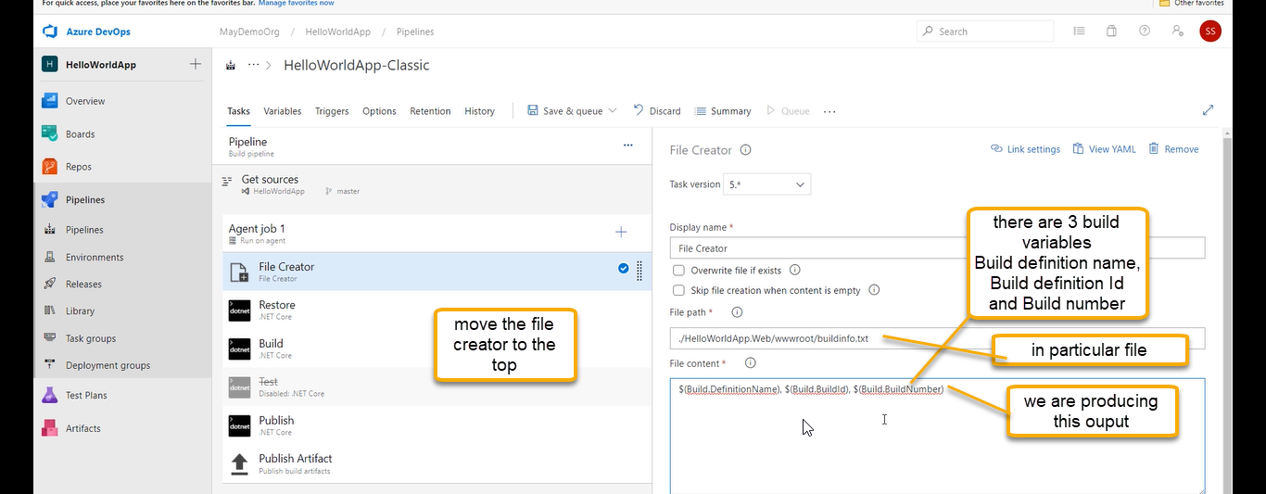

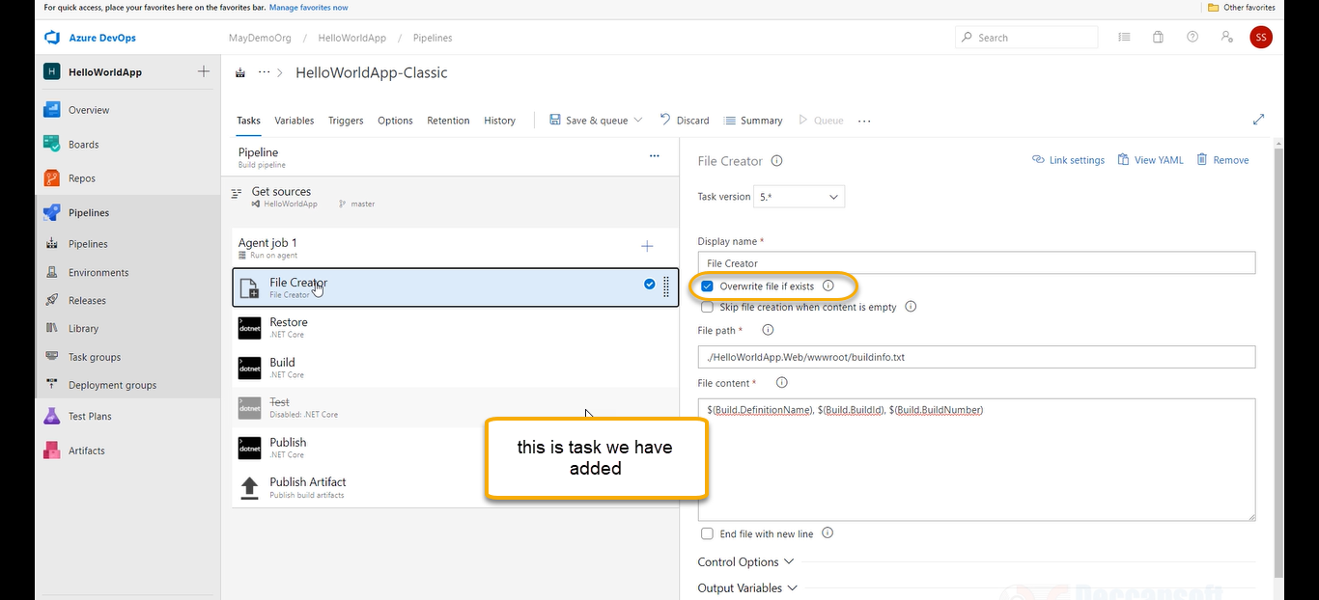

Add one more task command line

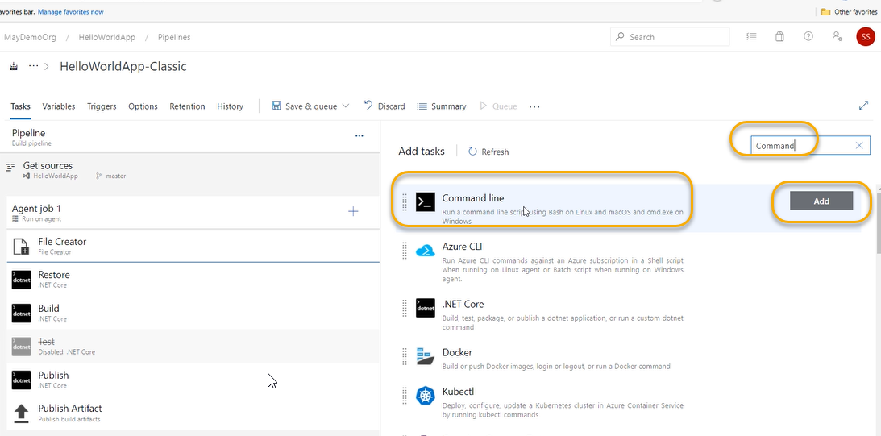

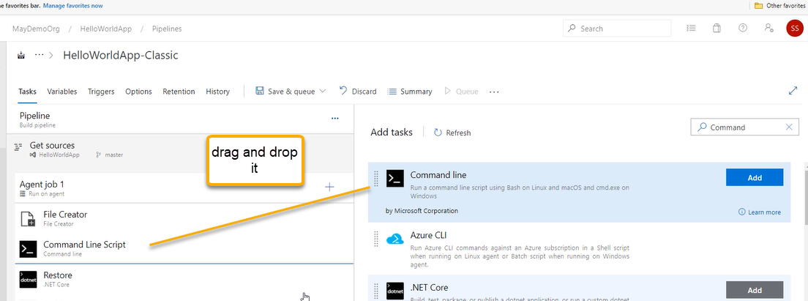

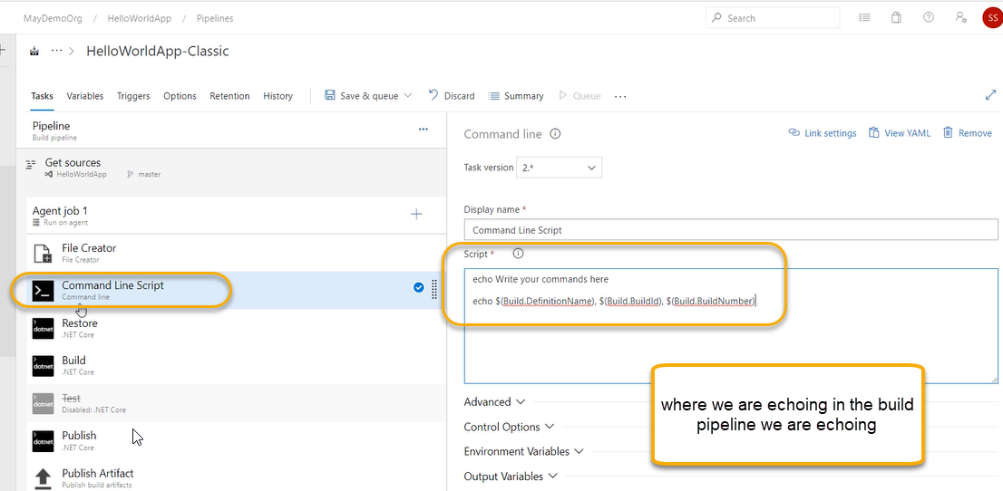

Its like during the build at the command prompt it will do echo

Command line script is echoing the string

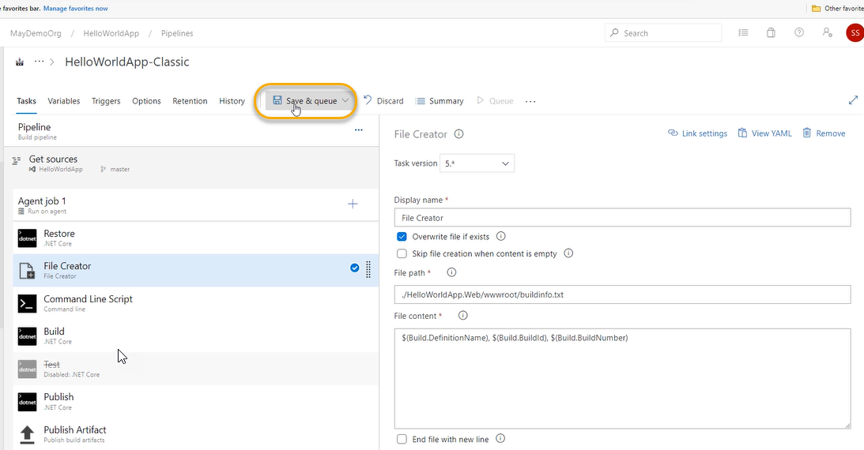

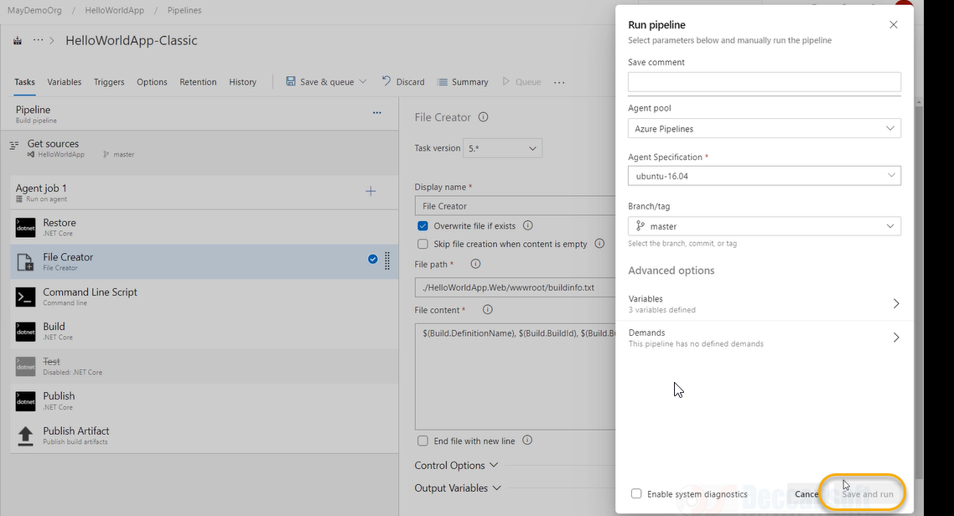

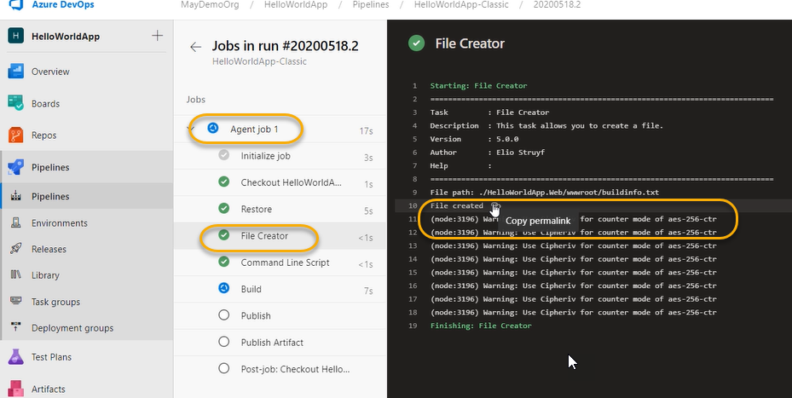

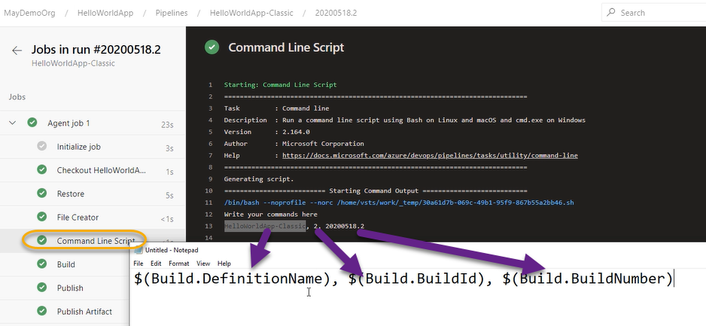

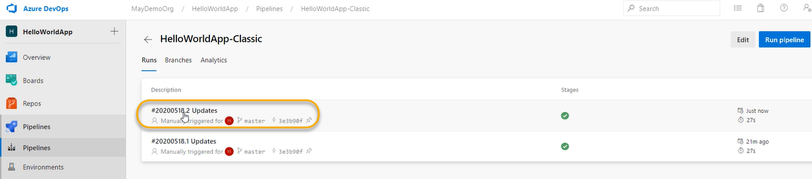

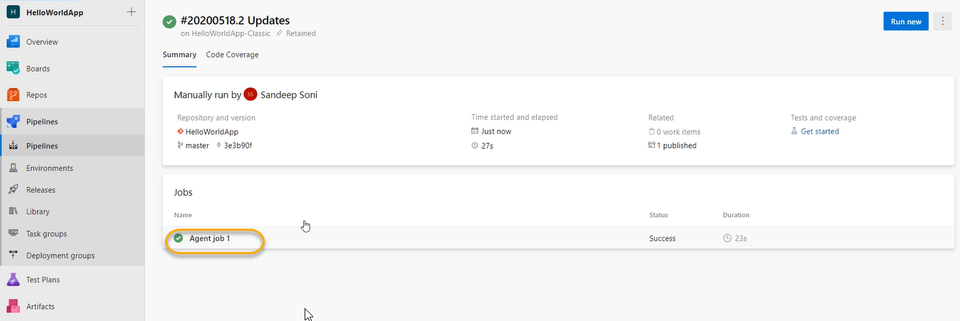

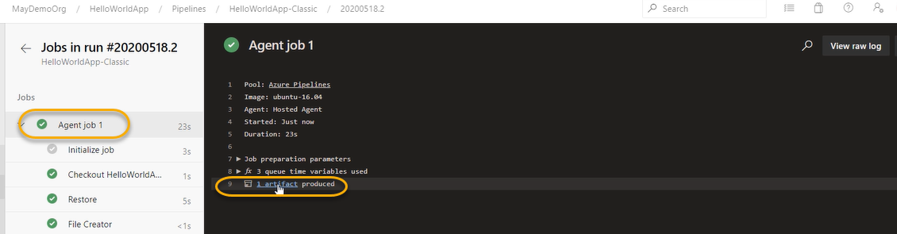

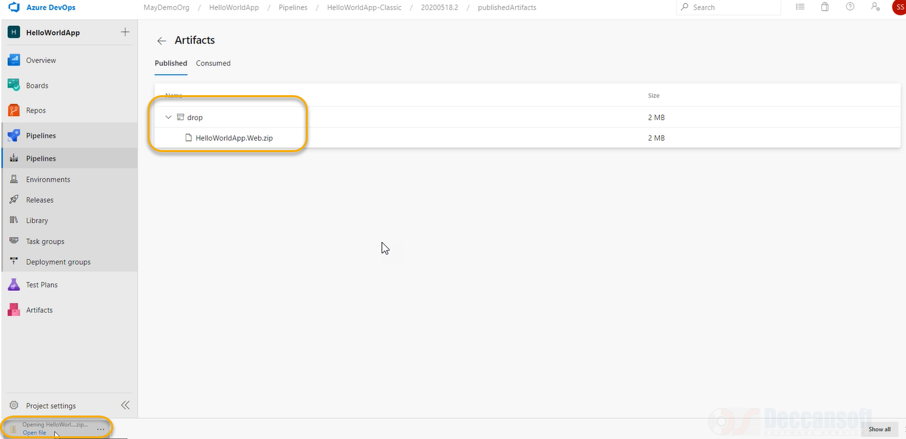

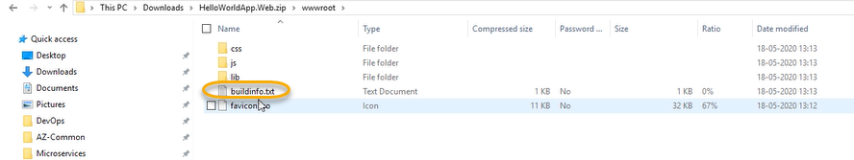

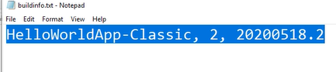

Any command can be executed in build pipeline

For now, we are excliplity saving the queue but our requirement as soon when commit happens in Repo I need to run the pipeline

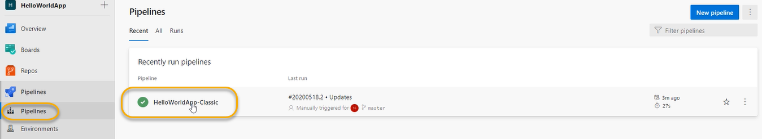

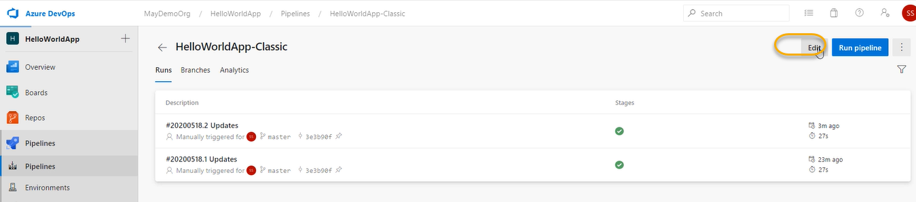

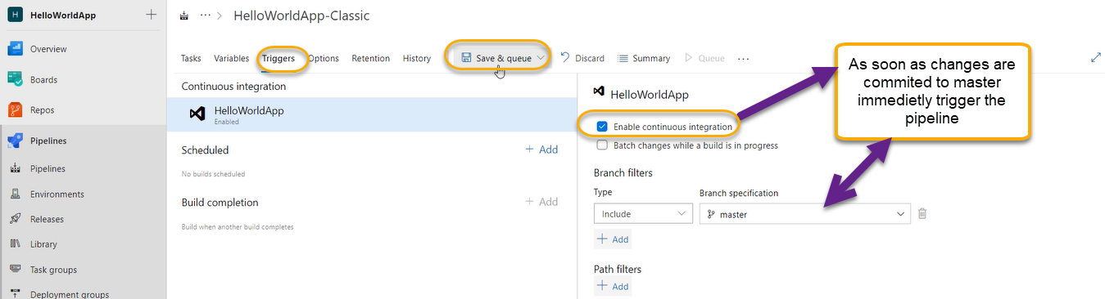

Do the save AND NOT THE QUEUE

Go to Command prompt line edit the code

Code .

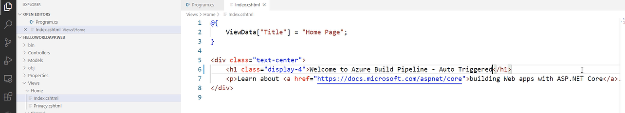

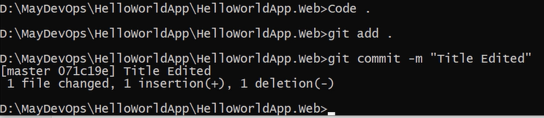

As of now nothing is triggered

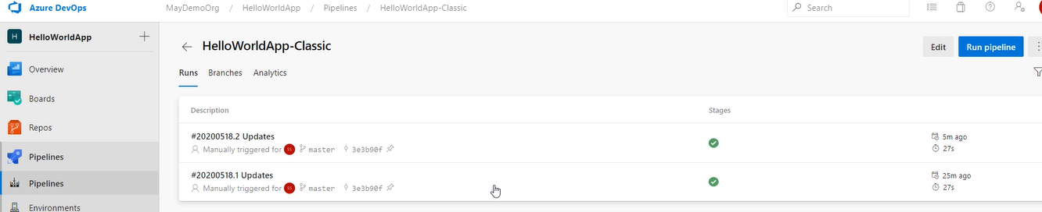

And now push the code to master

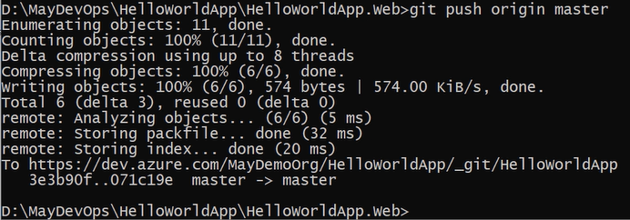

The pipeline has started automatically

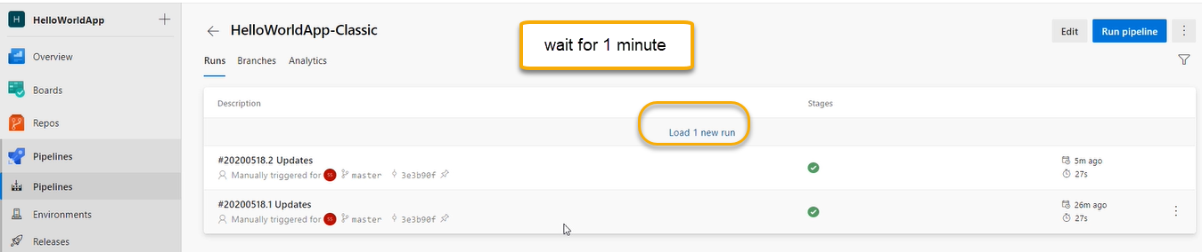

Click on load 1 new run

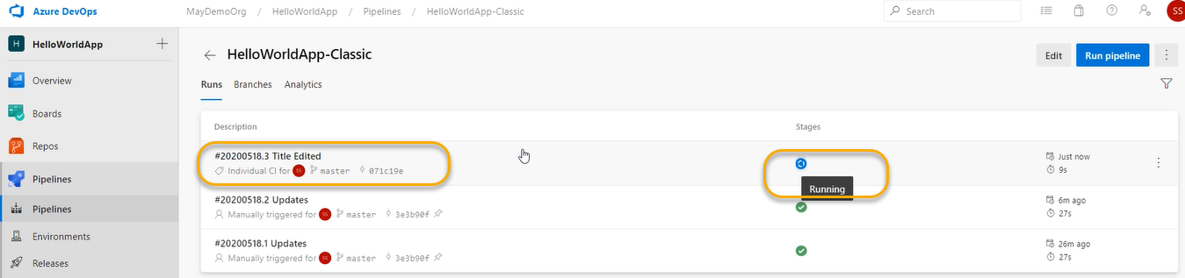

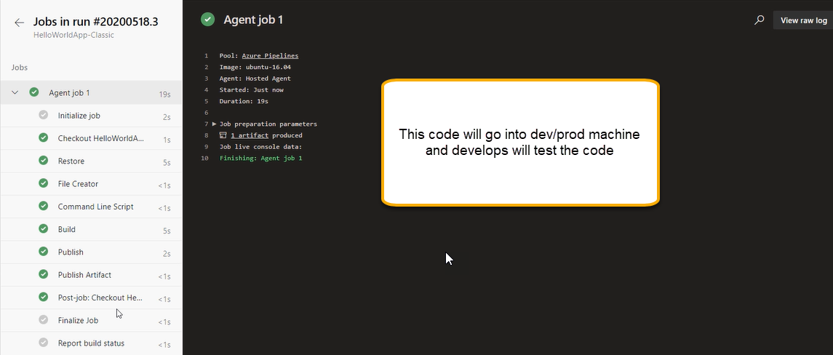

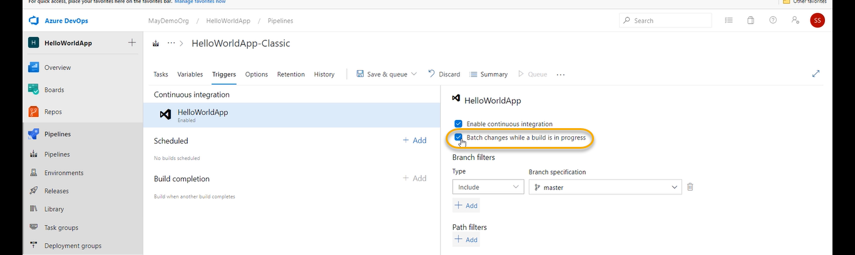

If 10 developers working on the same build if 10 commits and 10 push happens should it be there 10 RUNS or combinedtogetherthere should be single Run

If we check the above highlighted option, all commits can be combined together, and a single build will run all of them a separate build will not run on each of them

If you Uncheck the above highlighted option for each commit there should be each build will be triggered

A push by each user will create a separate Run.

The recommended process is to check the above highlighted option.

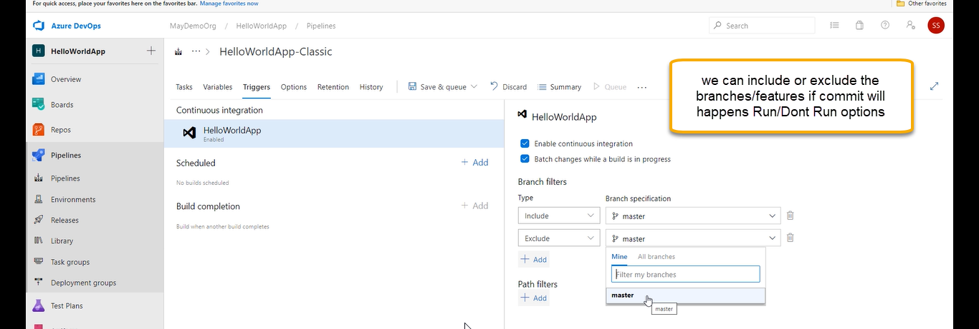

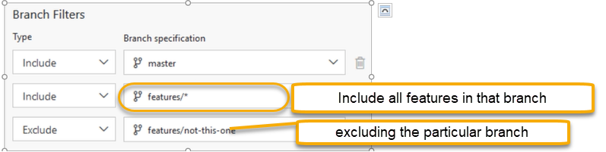



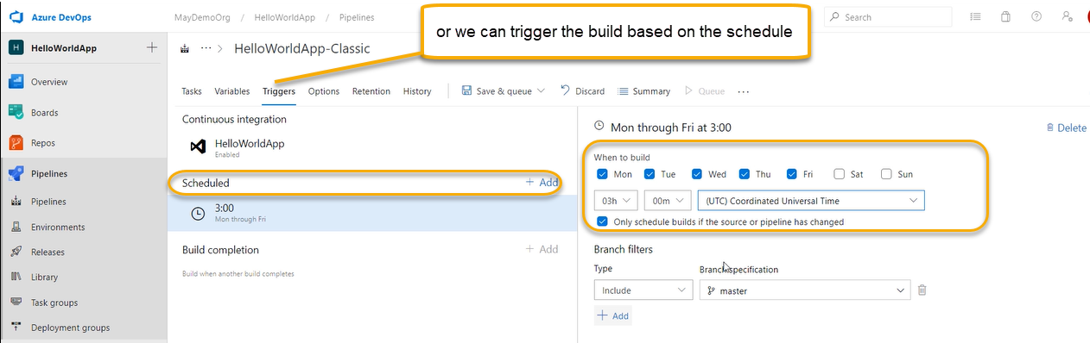

For schedule what ever there in the code/branch automatically it will be picked up and artifact will be created

Working with Task groups

When we create the CI pipeline using the classic pipeline it made of tasks some of tasks, we need to repeat in multiple places basically we need to consolidate and treat them in a single task

Multiple tasks together as one unit

We are going to group a task and when we create a task group it will added as a list here

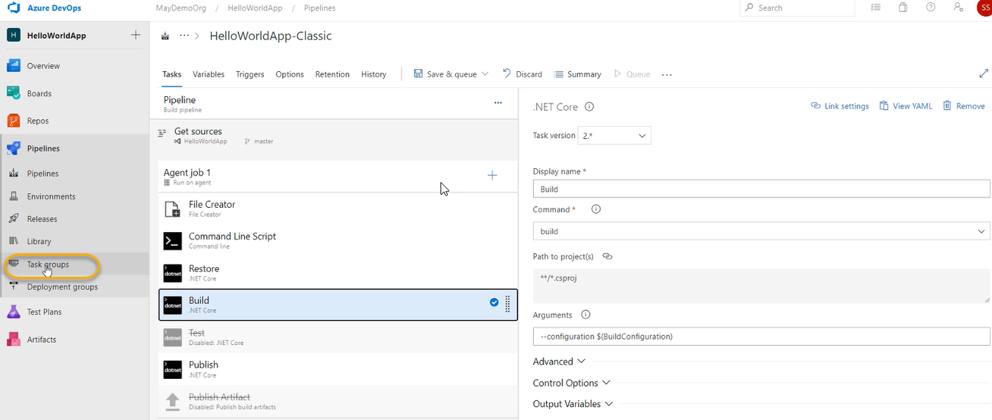

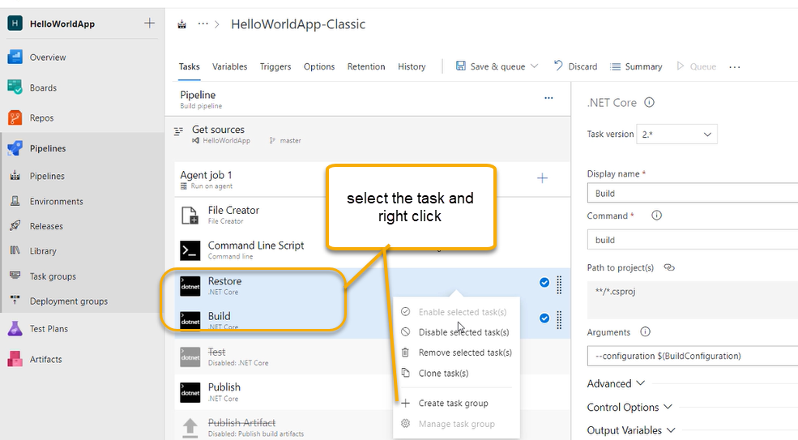

We need to make sure that what are all the things we need input and in that task we need to use variables in that

For which ever parameter of a task you want to become a parameter for that task group in the above screenshot Arguments are variable and Display name, command and project are constant.

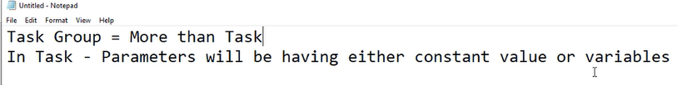

In build and restore we have a common property called project (path to project) and I want to use project parameter as a parameter now

If want this particular thing(path to project) to become a parameter of task group this should become a variable we are unable to edit this property because it is a linked property

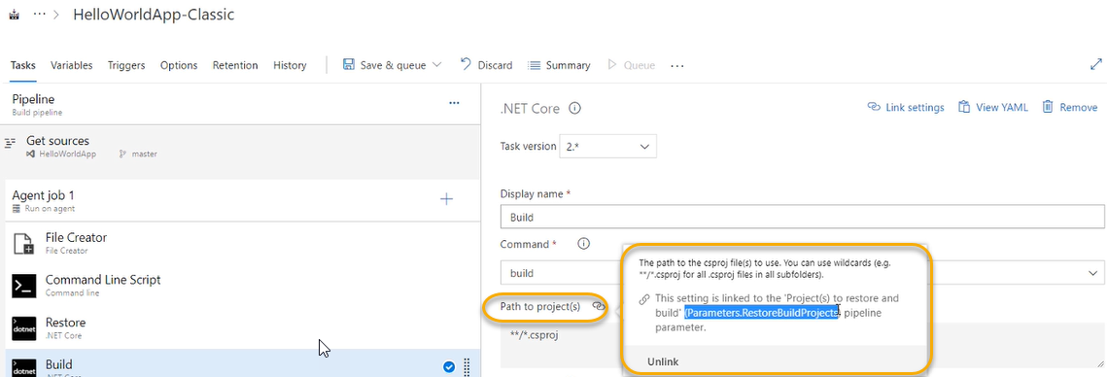

And whatever we will mention in the parametersin pipe line and we the same in (Restore) and we the same in the (Build)because it is a variable and linked property

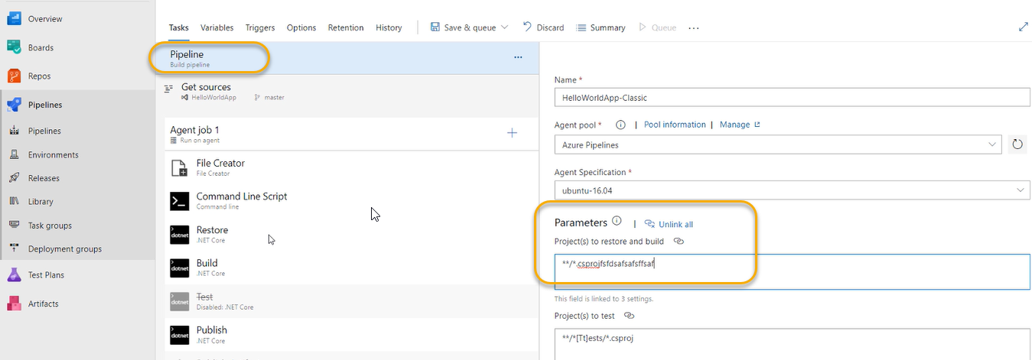

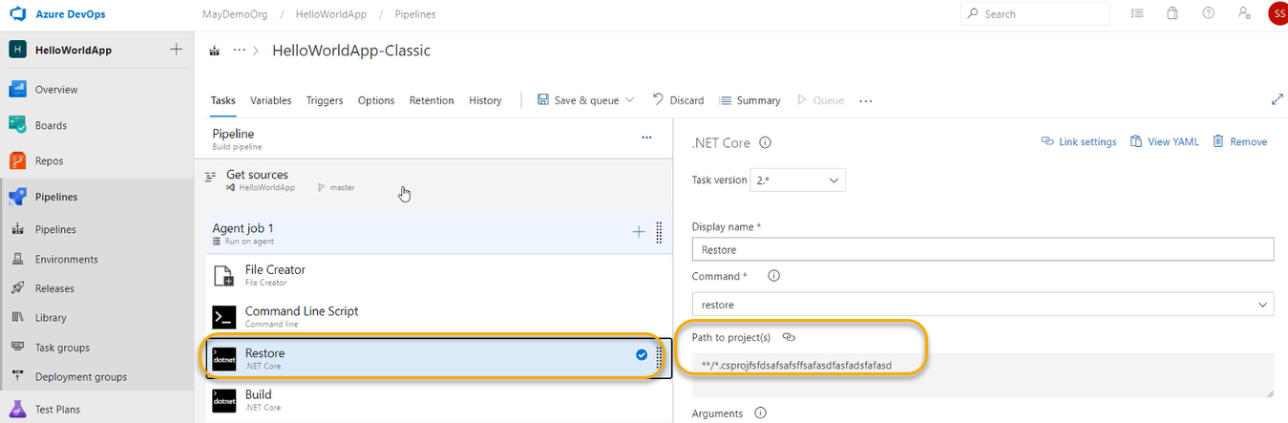

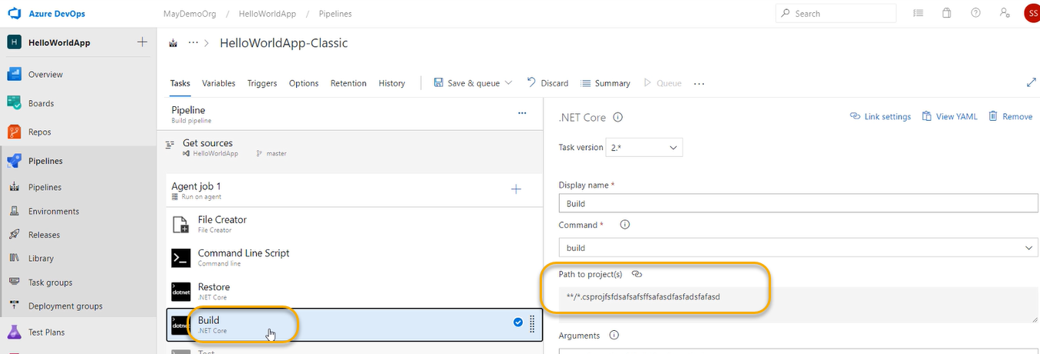

We need to delink this

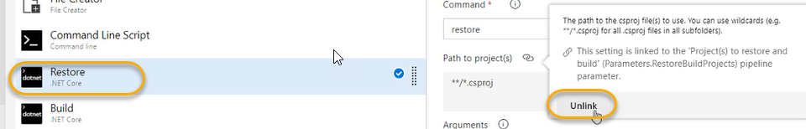

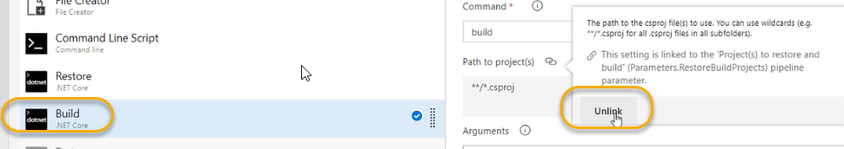

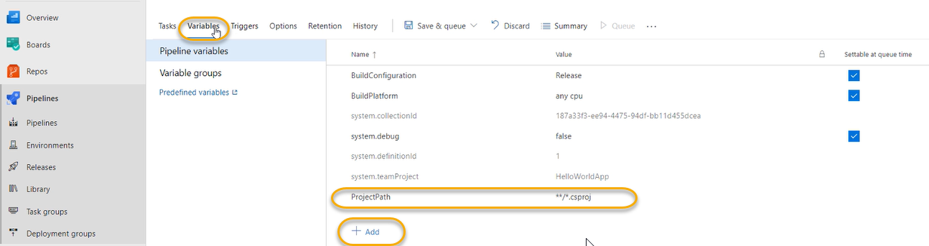

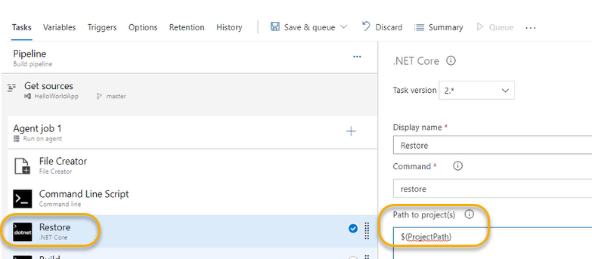

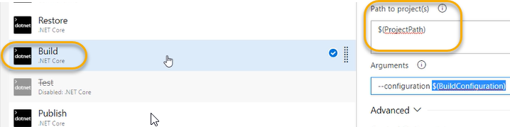

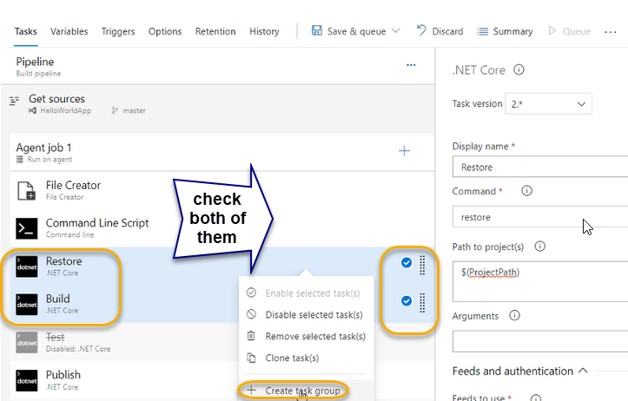

Variables in the task becomes the parameter in the task group automatically

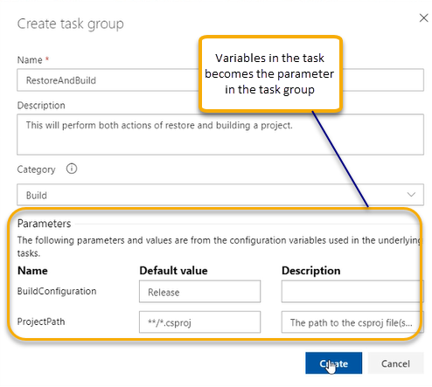

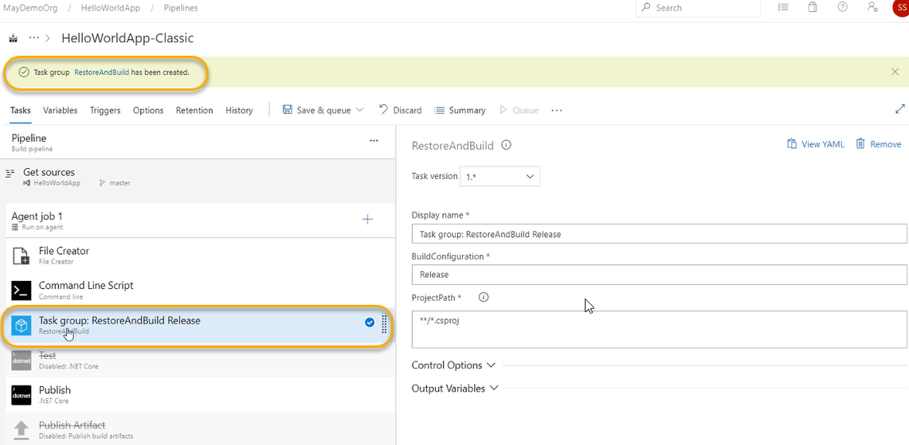

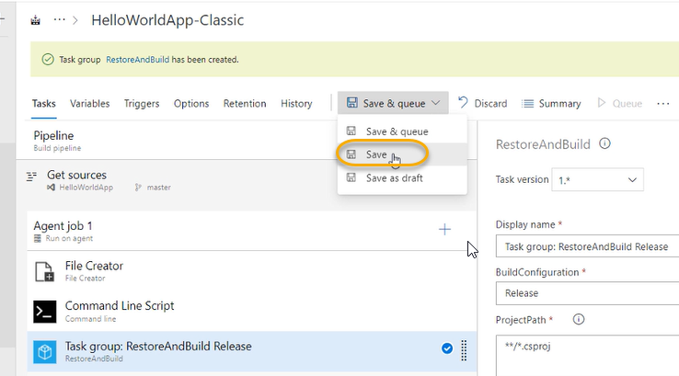

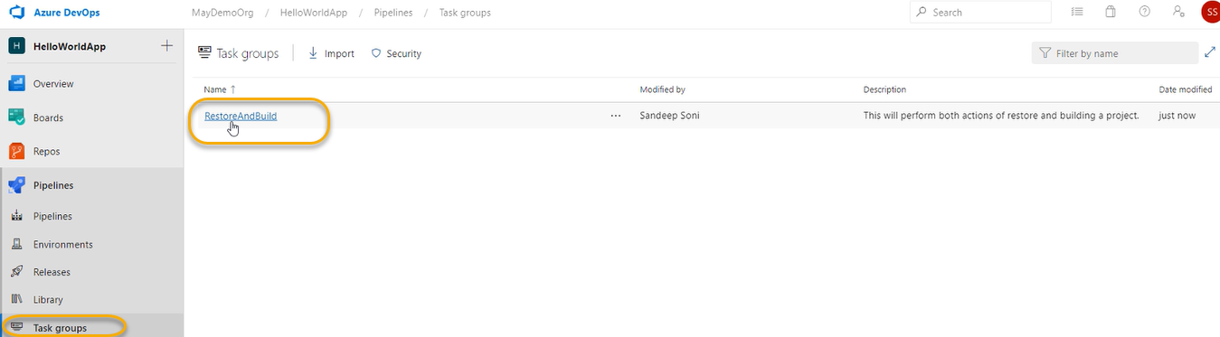

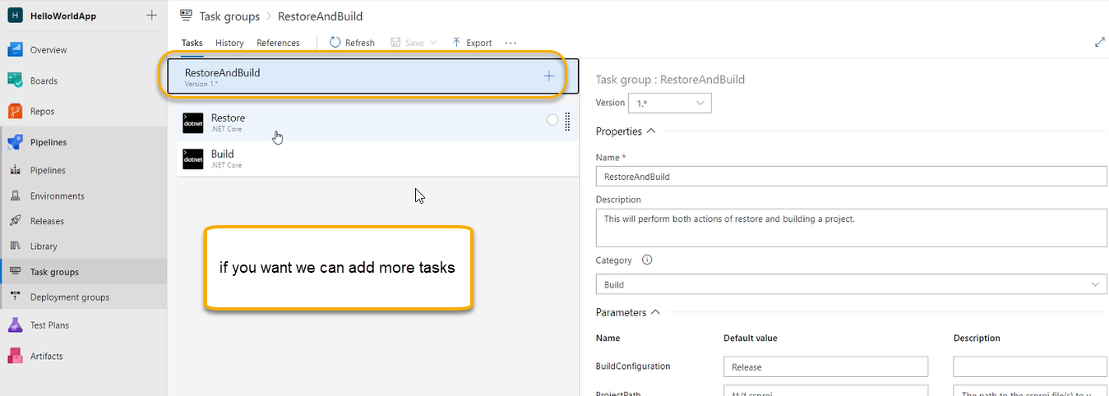

Even though if we delete it from below

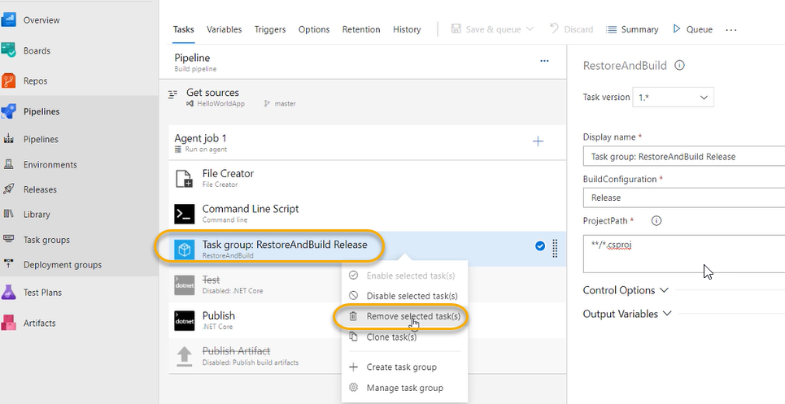

We can restore it again from Agent Job

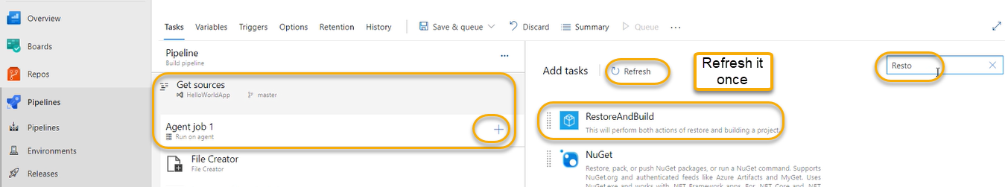

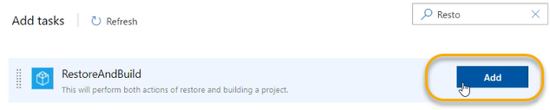

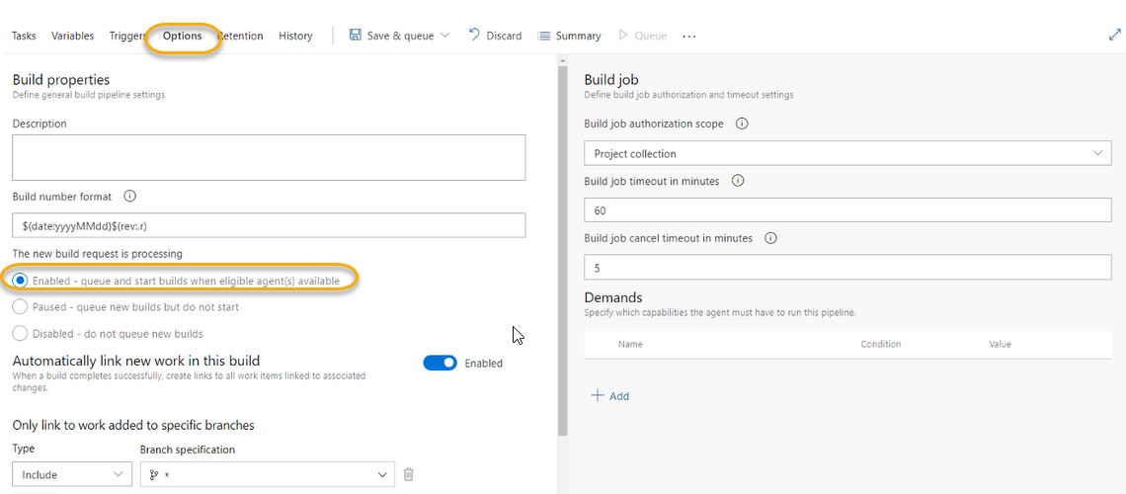

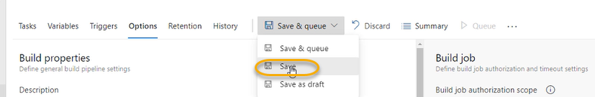

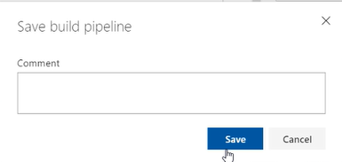

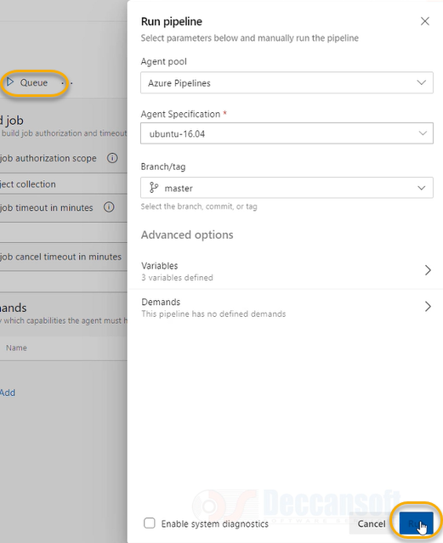

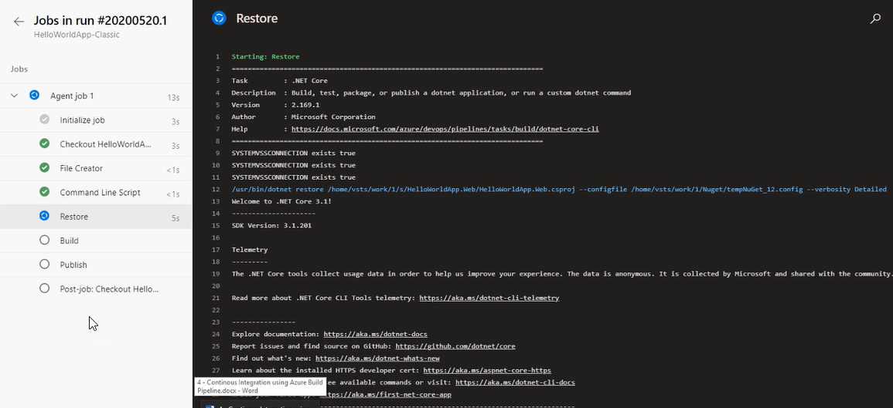

We achieved the Reusability

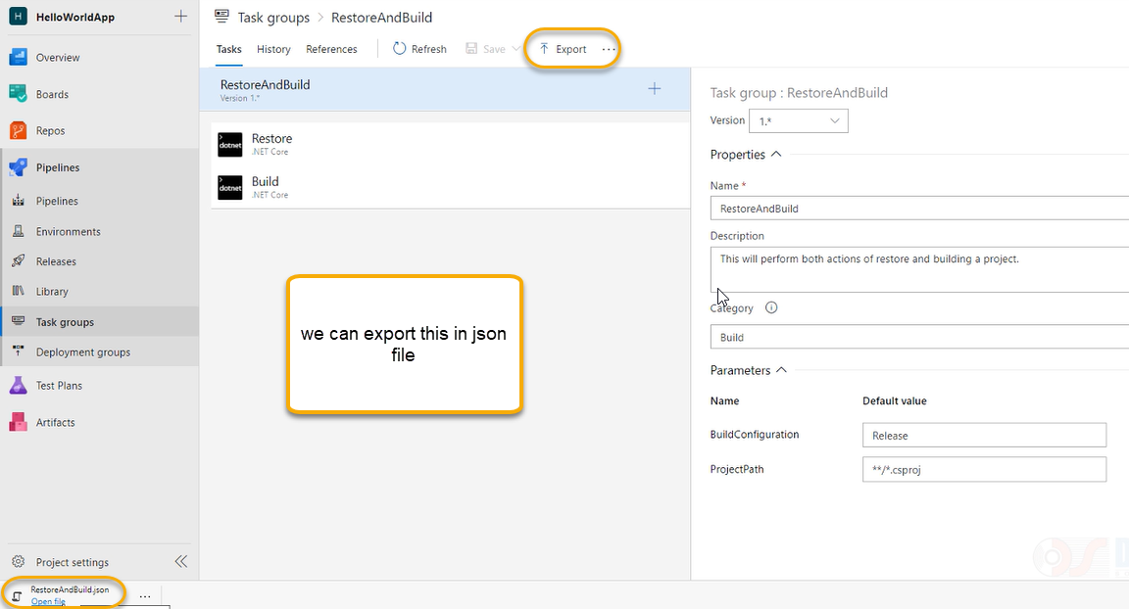



This Jason file we will save on it on your disk

And we can import it from the below way

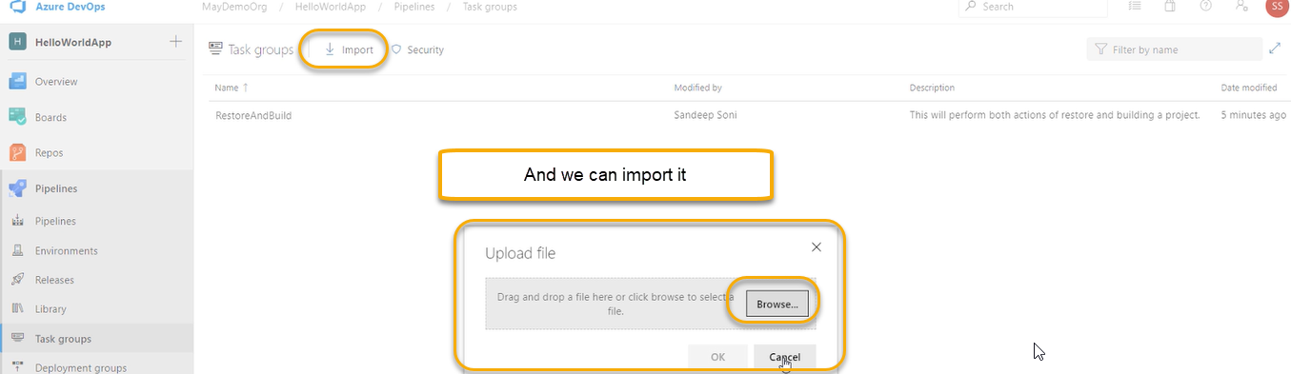

In real time scenarios we usually have 15 tasks and place under one task